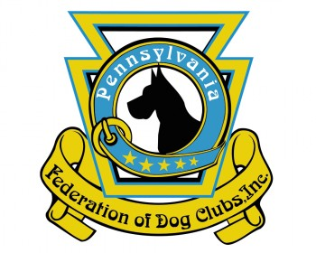
To: Senator John Fetterman
From: PA Federation of Dog Clubs
Re: S.2555 “Better Care of Animals” Bill
Date: February 22, 2024

Senator Fettermen,
The Pennsylvania Federation of Dog Clubs and its many member organizations across the Commonwealth are very concerned about the “Better Care of Animals” proposal currently under consideration in Congress. We do not believe the proposal will have the effect its name implies, but will, in fact, achieve the opposite result.
Removing subject matter experts from the enforcement of the Animal Welfare Act is inefficient and counter productive. Inspectors at the Department of Agriculture have spent decades learning animal husbandry practices at a practical level, instead of a political one. The Department of Justice on the other hand has shown itself to be strongly affected by the political winds on the day. We know that some vocal activists make a living out of vilifying traditional agricultural practices and we are sure those will be the voices heard by lawyers at the Department of Justice. Hopefully, legal representatives of farmers will be able to show this in court, but that will take significant financial resources and time out of the fields for our farmers. This undoubtedly have the effect of driving up food and other costs even faster than they are today.
The way S.2555 is written, it will cause redundancy between the Departments of Agriculture and Justice, wasting taxpayer dollars. The Department of Agriculture already requests DOJ assistance as necessary.
Another concern for us is the implication in the proposal that hobby breeders be treated the same as professional breeders. This will cause a greater caseload strain and reduce the effectiveness of current inspections, regardless of which Department is conducting them. This strikes us as part of a radical animal activist agenda to end hobby breeding, showing, trialing and other family friendly activities Americans enjoy with their animals. Siezing animals and forcing owners to pay for boarding prior to their day in court, and not allowing for refund of those fees should they be acquitted is an Unconstitutional seizure of property without due process.
We would much rather see Congress increase support for USDA/APHIS inspection activities in support of the Animal Welfare Act as it stands today.

